**-- Question 1: How many unique manufacturers / makers are there in the 2-wheeler category?**

SELECT

COUNT(DISTINCT maker) AS number_of_makers

FROM ev_sales_db.electric_vehicle_sales_by_makers

WHERE vehicle_category = '2-Wheelers'

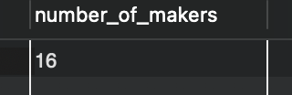

**-- Question 2: List the top 3 makers for the fiscal years 2023 and 2024 in terms of the number of 2-wheelers sold.**

SELECT maker,

SUM(electric_vehicles_sold) AS total_sold

FROM ev_sales_db.electric_vehicle_sales_by_makers evm

JOIN dim_date

USING(date)

WHERE vehicle_category = '2-Wheelers' AND fiscal_year IN (2023, 2024)

GROUP BY maker

ORDER BY total_sold DESC

LIMIT 3

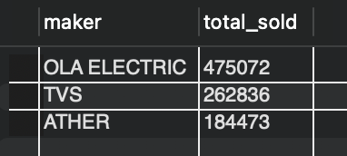

**-- Question 3: What is the average number of total vehicles sold per month in fiscal year 2024?**

WITH CTE AS (

SELECT

EXTRACT(MONTH FROM dd.date) AS month,

SUM(evs.total_vehicles_sold) AS total_vehicle_sales

FROM ev_sales_db.electric_vehicle_sales_by_state evs

JOIN ev_sales_db.dim_date dd ON evs.date = dd.date

WHERE dd.fiscal_year = 2024

GROUP BY month

)

SELECT

round(AVG(total_vehicle_sales),0) AS avg_total_sales_per_month

FROM CTE

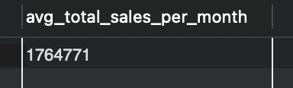

**-- Question 4: Identify the top 5 states with the highest penetration rate in 2-wheeler and 4-wheeler EV sales in FY 2024.**

SELECT

state,

round((SUM(electric_vehicles_sold) / SUM(total_vehicles_sold)) * 100 , 2) AS penetration_rate

FROM ev_sales_db.electric_vehicle_sales_by_state evs

JOIN ev_sales_db.dim_date dd ON evs.date = dd.date

WHERE fiscal_year = 2024 AND vehicle_category IN ('2-Wheelers', '4-Wheelers')

GROUP BY state

ORDER BY penetration_rate DESC

LIMIT 5

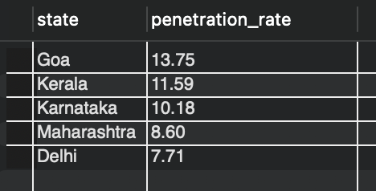

**-- Question 5: Which states recorded the highest and lowest total vehicle sales in fiscal year 2023?**

WITH CTE AS (

SELECT

evs.state,

SUM(evs.total_vehicles_sold) AS total_vehicle_sales

FROM ev_sales_db.electric_vehicle_sales_by_state evs

JOIN ev_sales_db.dim_date dd ON evs.date = dd.date

WHERE dd.fiscal_year = 2023

GROUP BY evs.state

)

SELECT

ss.state,

ss.total_vehicle_sales

FROM CTE ss

WHERE ss.total_vehicle_sales = (SELECT MAX(total_vehicle_sales) FROM CTE)

OR ss.total_vehicle_sales = (SELECT MIN(total_vehicle_sales) FROM CTE)

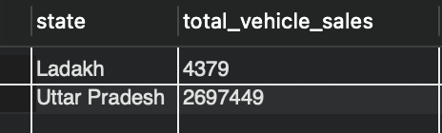

**-- Question 6: What are the peak and low season months for EV sales based on the data from 2022 to 2024?**

SELECT

DATE_FORMAT(date, '%M') AS month_name,

SUM(evs.electric_vehicles_sold) AS total_ev_sales

FROM ev_sales_db.electric_vehicle_sales_by_state evs

JOIN dim_date dd

USING(date)

WHERE dd.fiscal_year BETWEEN 2022 AND 2024

GROUP BY month_name

ORDER BY total_ev_sales DESC

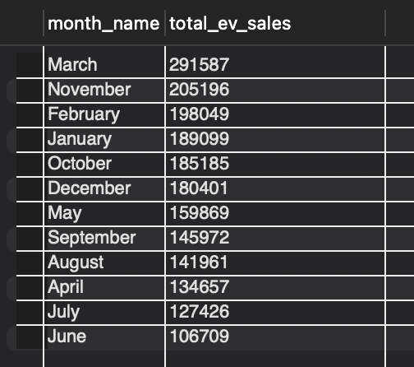

**-- Question 7: List the compounded annual growth rate (CAGR) in 2-wheelers units for the top 4 makers from 2022 to 2024.**

WITH cagr_data AS (

SELECT

maker,

SUM(CASE WHEN fiscal_year = 2022 THEN electric_vehicles_sold ELSE 0 END) AS start_value,

SUM(CASE WHEN fiscal_year = 2024 THEN electric_vehicles_sold ELSE 0 END) AS end_value

FROM ev_sales_db.electric_vehicle_sales_by_makers evm

JOIN ev_sales_db.dim_date dd ON evm.date = dd.date

WHERE vehicle_category = '2-Wheelers'

GROUP BY maker

ORDER BY end_value DESC

LIMIT 4

)

SELECT

maker,

round((POWER((end_value / start_value), 1 / 2.0) - 1) * 100, 2) AS cagr_percentage

FROM cagr_data

ORDER BY cagr_percentage DESC

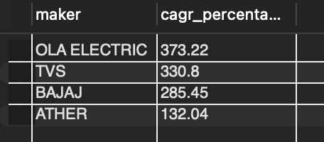

**Question 8: Categorize the states based on electric vehicle penetration rates in fiscal year 2024, with classifications of Above 7%, Above 5%, Above 3%, Above 1%, and Below 1%**

SELECT

evs.state,

SUM(evs.electric_vehicles_sold) AS total_ev_sales,

SUM(evs.total_vehicles_sold) AS total_vehicles_sold,

SUM(evs.electric_vehicles_sold) / SUM(evs.total_vehicles_sold) * 100 AS penetration_rate,

CASE

WHEN (SUM(evs.electric_vehicles_sold) / SUM(evs.total_vehicles_sold)) * 100 > 7 THEN 'Above 7%'

WHEN (SUM(evs.electric_vehicles_sold) / SUM(evs.total_vehicles_sold)) * 100 > 5 THEN 'Above 5%'

WHEN (SUM(evs.electric_vehicles_sold) / SUM(evs.total_vehicles_sold)) * 100 > 3 THEN 'Above 3%'

WHEN (SUM(evs.electric_vehicles_sold) / SUM(evs.total_vehicles_sold)) * 100 > 1 THEN 'Above 1%'

ELSE 'Below 1%'

END AS penetration_category

FROM ev_sales_db.electric_vehicle_sales_by_state evs

JOIN ev_sales_db.dim_date dd ON evs.date = dd.date

WHERE dd.fiscal_year = 2024

GROUP BY evs.state

ORDER BY penetration_rate DESC

